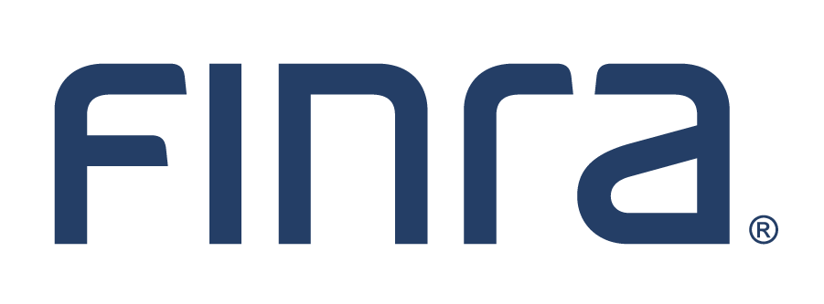
Attn: Trading and Market Making/Legal and Compliance/Operations/Systems
UNIFORM PRACTICE ADVISORY (UPC #119-25) 11/13/2025 Global Medical REIT Inc. Cumulative Redeemable Preferred Series B (When Issued) GMRBV

As noted on the 11/13/2025 Daily List, the symbol GMRBV has been issued for Global Medical REIT Inc. Cumulative Redeemable Preferred Series B (When Issued). FINRA is issuing this UPC Advisory to alert members, investors and other interested parties to the following general information regarding the issuance of a symbol for when, as and if issued contracts:
- The issue of whether a "when, as and if issued" contract is bona fide and/or is subject to any requirements or prohibitions under the federal securities laws in respect of any transaction or any person is a matter not addressed by the issuance of a trading symbol. Those questions are matters of interpretation under the federal securities laws and are neither within the scope of FINRA responsibilities under the Uniform Practice Code nor will otherwise be addressed by FINRA. Consequently, any party that may have any responsibility under the federal securities laws and/or FINRA Rules for certain conduct or transactions may not rely on the issuance of a trading symbol as permitting, excusing or mitigating any volatile conduct;
- The issuance of a symbol does not otherwise represent a review by FINRA of the merits of such contracts and/or its terms or the requirement or adequacy of any disclosures; and
- Members are expected to comply with their obligations under Uniform Practice Code Rule 11130 and all other related rules in respect of such contracts, including, but not limited to, Regulation SHO, as applicable. Members should ensure that they understand the application of, and can comply with, these provisions prior to effecting transactions in these securities.

Questions regarding this notice should be directed to: FINRA Market Operations-
1-866-776-0800.

